Computer Language Diagrams

Object Assignment in a Diagram
About the notation of assignment in general, see the article Assignment in a Diagram.

The principle of object assignment is explained in the article Object Assignment. This article demonstrates the expression of it in a diagram.

To distinguish object assignment from other types of assignment such as value assignment, object assignment gets a special symbol:

This symbol is the identifier for object assignment.
It is an equals sign with an O in it, which stands for object.

As such, a value assignment in a diagram looks like this:

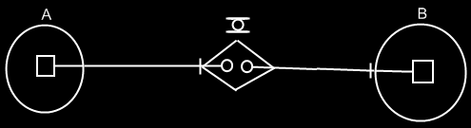

See also: Assignment in a Diagram, Object Assignment

Author & Copyright: Jan-Joost van Zon Date: May 24, 2008 – May 24, 2008 Location: Oosterhout, The Netherlands Status: Finished

